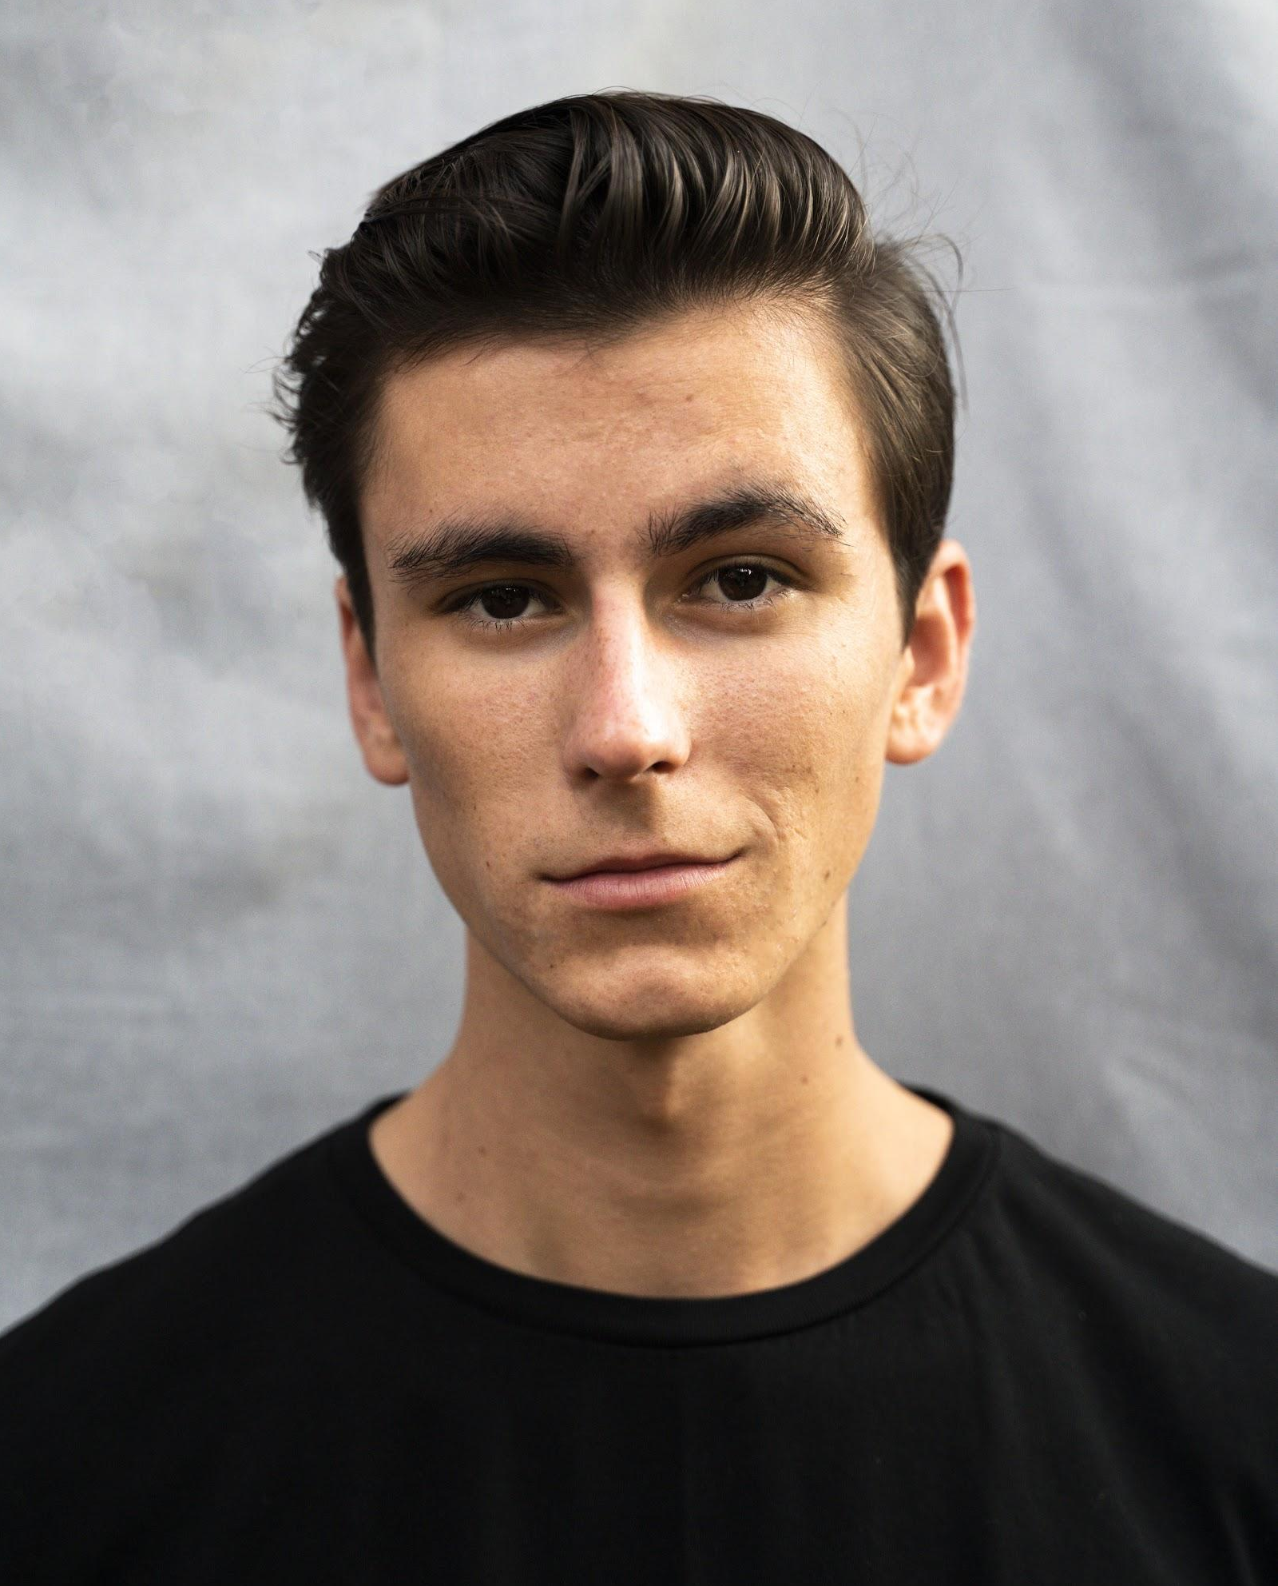
GRANT WILLIAMS
Email: grantwilliamsacts@gmail.com
Phone: (904)874-2227
Height: 5’11
Weight: 135lbs
Hair/Eye Color: Brown
Theatre
The Tragedy of Julius Caesar  Measure for Measure  Lend Me a Tenor  Almost, Maine  Para(Normals)  Trip of a Lifetime | Caesar  Angelo  Max  Jimmy & Pete  Nathan  Victor | Institute of Arts Barcelona/Drew Mulligan  Nubox Theatre/Mark Thomas Johnson  Neptune Beach Theatre/Tom Ming  Players by the Sea/Bradley Akers  Theatre Row/Haruna Lee  N.O.W. Festival/Michelle Chan
Film
The Fantastic Death of Barry Schmidt | Supporting | FSU Film School/Zach Hardy
Training
Pace University BA Acting- International Performance Ensemble
Institute of the Arts Barcelona(IAB)
Accents/Dialects  Script Analysis  Shakespeare  Contact Improv  Devised Theatre  U Unarmed Combat  Theatre History  Business of Acting  Vocal Training/Fitzmaurice  Movement/Meyerhold  Stanislavski  Meisner  Lecoq  Grotowski | Kate Firth  Thomas Keith  Drew Mulligan  Mike Mikos  Ianthe Demos  Michael G. Chin  Armando Rotondi  Caroline Liem  Josh Moser  Jon Froelich  Cosmin Chivu, Carter Gill  Sebastian Tudores  Adrienne Kapstein, Berty Tovias  Nora Woolley, Pei Hwee Tan, Francesc Torrent
Special Skills
Proficient at any sport involving a ball or standing on a board including baseball, basketball, football, tennis, skateboarding, snowboarding, skiing, and surfing. Intermediate dance training in hip-hop, tap, jazz, waltz, tango, samba, and swing. Available dialects include Cockney, RP, and I am certified in unarmed stage combat. I'm a pretty good beatboxer and love to do art like painting, drawing, and spray painting. You may have even seen some of my graffiti around the city, keep an eye out for the tag “Dubb.”

